***Lab 2***

1- ALTER TABLE Students

-> ADD COLUMN Gender ENUM('male', 'female');

2- mysql> ALTER TABLE Students ADD COLUMN BirthDate DATE;

3- mysql> alter table Students

-> drop column Name;

mysql> alter table Students

->add column FirstName VARCHAR(10);

mysql> alter table Students

-> modify column FirstName VARCHAR(10) after ID;

mysql> alter table Students add column LastName VARCHAR(10);

mysql> alter table Students modify column LastName VARCHAR(10) after FirstName;

4- mysql> alter table Student_Phone add constraint foreign key(StudentID) references Students(ID) on delete cascade;

5- mysql> UPDATE Students set Gender = 'female' where ID = 4;

mysql> UPDATE Students set Gender = 'female' where ID = 5;

mysql> UPDATE Students set Gender = 'male' where ID IN (2,3);

mysql> update Students set BirthDate = '1997-03-03' where ID = 1;

mysql> update Students set BirthDate = '1991-10-01' where ID = 2;

mysql> update Students set BirthDate = '1988-12-13' where ID = 3;

mysql> update Students set BirthDate = '1970-05-07' where ID = 4;

mysql> update Students set BirthDate = '1994-06-04' where ID = 5;

mysql> update Students

-> set FirstName = (case when ID = 1 then 'Asmaa'

when ID = 2 then 'Mohamed'

when ID = 3 then 'Ahmed'

when ID = 4 then 'Maha'

when ID = 5 then 'Lora'

end);

mysql> update Students set LastName = (case when ID = 1 then 'Hamada'

when ID = 2 then 'Omar'

when ID = 3 then 'Ibrahim'

when ID = 4 then 'Mansour'

when ID = 5 then 'Qandeel'

end);

7-

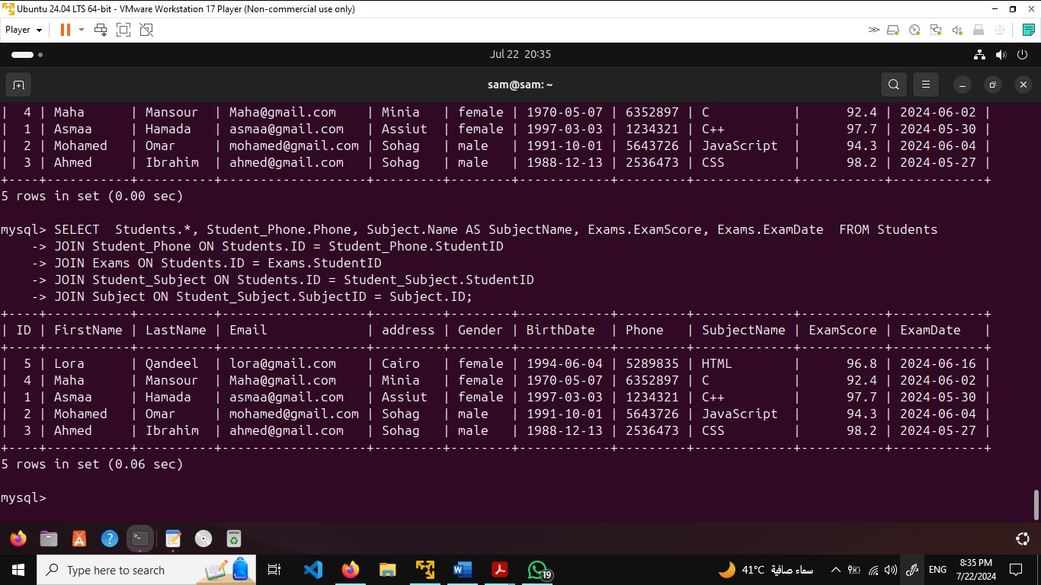

8-

9-

10-

11-

12-

13-

14-

15-

16- mysql> SELECT FirstName, COUNT(*) FROM Students GROUP BY FirstName HAVING COUNT(*) > 2;

17-

mysql> CREATE VIEW StudentTracks AS SELECT Students.FirstName, Tracks.TrackName FROM Students JOIN Tracks ON Students.TrackID = Tracks.

TrackID;

18-

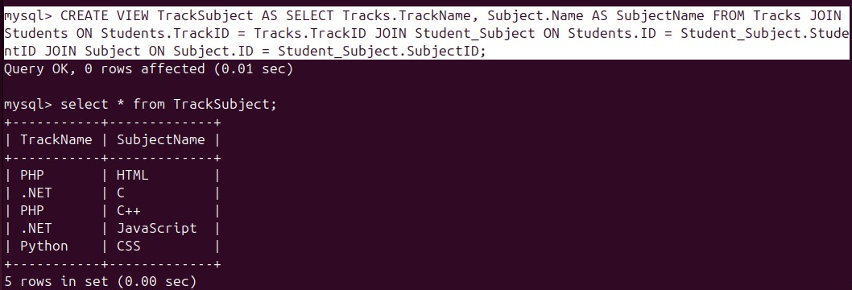

19-

mysql> CREATE VIEW StudentSubjects AS SELECT Students.FirstName, Subject.Name AS SubjectName FROM Students JOIN Student_Subject ON Students.ID = Student_Subject.StudentID JOIN Subject ON Student_Subject.SubjectID = Subject.ID;

20-

21-

***Lab3***

1-

mysql> START TRANSACTION;

mysql>

mysql> INSERT INTO Students (FirstName, LastName, Email, address)

-> VALUES ('Omar', 'Ahmed', 'omar@gmail.com', 'Alexandria');

mysql> DECLARE @NewStudent INT;

mysql> SET @NewStudent = LAST_INSERT_ID();

mysql> INSERT INTO Student_Phone (StudentID, Phone)

-> VALUES (@NewStudent, '7783784');

mysql> INSERT INTO Exams (StudentID, SubjectID, ExamScore)

-> VALUES (@NewStudent, @NewStudent, 85),

-> (@NewStudent, @NewStudent, 90),

-> (@NewStudent, @NewStudent, 78);

mysql>

mysql> COMMIT;

2-

3-

4-

5-

6-

mysql> INSERT INTO Exams (StudentID, SUbjectID, ExamScore, ExamDate) VALUES (6,6, 85, NOW());

7-

8-

DELIMITER //

CREATE FUNCTION MultiplyNumbers (a FLOAT, b FLOAT)

RETURNS FLOAT

DETERMINISTIC

BEGIN

RETURN a * b;

END //

DELIMITER ;

9-

DELIMITER //

CREATE FUNCTION GeExamScore(StudentID INT, exam_id INT)

RETURNS INT

DETERMINISTIC

BEGIN DECLARE exam_score INT;

SELECT ExamScore

INTO exam_score FROM exams

WHERE StudentID = StudentID AND SubjectID = exam_id;

RETURN exam_score;

END

DELIMITER ;

10-

def count_failed_students(exam_scores, exam_id):

failed_count = 0 for student_scores in exam_scores.values():

if exam_id in student_scores and student_scores[exam_id] < 50:

failed_count += 1 return failed_count

11- def average_max_grades(subject_max_scores, subject_idif subject_id not in subject_max_scores: return f"Subject with ID {subject_id} not found." max_score = subject_max_scores[subject_id] return max_score # Example usage subject_max_scores = { "subject_1": 100, "subject_2": 100 } subject_id = "subject_1" average_score = average_max_grades(subject_max_scores, subject_id) print(f"Average max grades for subject {subject_id}: {average_score}")

12-

CREATE TABLE Deleted_Students ( Name VARCHAR(100), Email VARCHAR(100), Address VARCHAR(255), id INT PRIMARY KEY );

13-

CREATE TRIGGER after_student_delete AFTER DELETE ON Students FOR EACH ROW BEGIN INSERT INTO Deleted_Students (Name, Email, Address, id) VALUES (OLD.Name, OLD.Email, OLD.Address, OLD.id); END;

14-

CREATE TABLE Backup_Students AS

SELECT * FROM Students WHERE 0;

CREATE TRIGGER after_student_insert

AFTER INSERT ON Students FOR EACH ROW BEGIN INSERT INTO Backup_Students (Name, Email, Address, id) VALUES (NEW.Name, NEW.Email, NEW.Address, NEW.id); END;

16-

sudo mysqldump --databases GradingDatabase > GradingDatabase.sql

17-

sudo mysqldump --databases GradingDatabase Students > students_table.sql

18-

sudo mysqldump --databases Grading_Backup < grading_database.sql